**Vfsv Files and Directories**

* ls this command shows all of the files and directories in the current directory.
  + Note: files and directories are noted in different colors for ubuntu typically directories are blue and files are white
* ls -R this command will allow you to see all of the files and directories in all of the directories including the sub directories
* ls -al this gives very detailed information about files

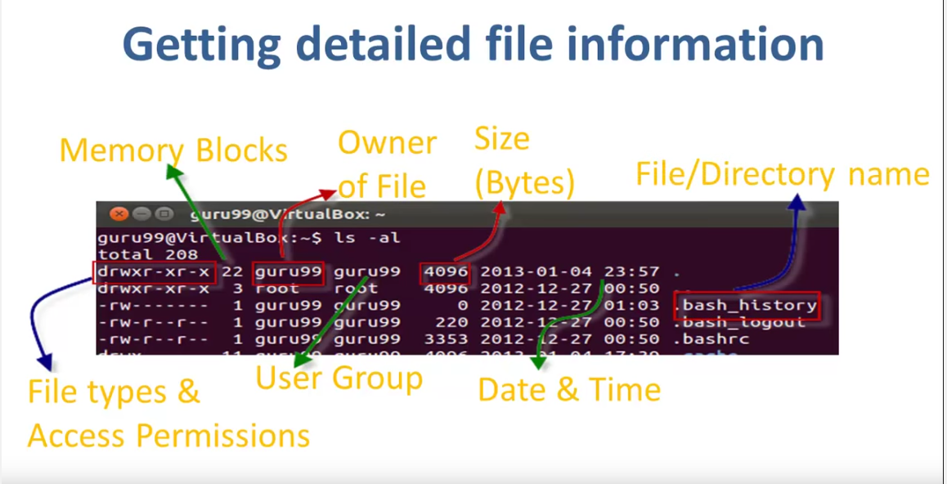

* ls -a this gives a list of all of the hidden files and folders
  + Note: this will not show up unless requested and all hidden files and folders start with a period.
* ls -l This will show you all of the permissions associated with the files.
* mkdir (directory name) This allows you to make a subdirectory in the present directory
* mkdir (directory name) (directory name) (directory name) this allows the user to create multiple directories at once.
* rmdir (directory name) this allows the user to delete directories.
* mv (directory name) (new directory name) this allows you to rename a directory
* cd (directory name) this will move the user to the directory specified.
* cd ~ this allows the user to go directly to the root directory
* pwd this command will print the current working directory
* locate (filename) this will search the entire computer for the file specified and show you the directory or location of that file
* mount cdrom this will allow you to turn on or mount the cd drive
* mount eject this will allow the user to eject the cd drive.
* cp (source directory) (destination directory) This will allow you to copy files or directories over to another location.
* gedit (filename) this will allow the user to open and edit the gedit file specified
* less (filename) this allows the user to display and look through a large file one line at a time.

**Creating text files**

* cat this command is used to display text files. It can also be used to copy, combine and create text files.
* cat > (name of file) this command creates a file the (name of file) is where you put the name of the file that you are creating. Once you type ad enter that you need to enter into the terminal the content of the text file. After the content has been typed into the terminal press ctrl and d in order to return to command prompt.
* cat (name of file) this command allows you to recall and view a text file
* cat (name of a file) (name of another file) > (name of new file) This command allows you to combine two text files into one text file.
  + Note: in order to view the new file use the cat (name of file) except insert the name of the new file
* rm (directory of file) this command allows you to delete files without a needed confirmation
* mv (name of file/directory) (new location/directory of desired location) This command lets you move files from one place to another
  + Note: this requires sudo or Superuser permissions
* mv (name of file/directory) (new file name) This changes the name of a file

man (command) This allows you to learn more about the command that you are confused about. It is similar to the help button on many softwares.

history this command allows you to look through all of the previous commands used in that terminal session.

Note: the up arrow allows you to go through the last command

clear this command allows the user to clean up all of the clutter and commands on the terminal window.

Note: In order to paste into a terminal window hold down ctrl + shift + v

**Linux Directory Structure:**

[**https://docs.google.com/a/stemhigh.org/document/d/14CDGPqPgV8M-m8sykhdaqSKh2PD7k42ZH40p8E22USg/edit?usp=sharing**](https://docs.google.com/a/stemhigh.org/document/d/14CDGPqPgV8M-m8sykhdaqSKh2PD7k42ZH40p8E22USg/edit?usp=sharing)

**Account**

* $ if you see this in the terminal it means that you are logged in as a standard user
* # If you see this in the terminal it means that you are logged in as a root user

* su (account name) This will allow you to log into accounts if you type this and then the name of the account you can log into the other account with the password.
  + Note: if you just type sudo su you can log into the root account with the root password
* whoami this command will allow you to see which account you are logged into. It will also tell if you are root or not.
* passwd (account name) this will allow you to change the password of the user that you put in.
  + Note: if you just enter passwd it will prompt you to change the password of the root account.
* id this command will give you your user iduf
* sudo sh -c 'printf "[SeatDefaults]\nallow-guest=false\n" > /etc/lightdm/lightdm.conf.d/50-no-guest.conf'
  + This disables guest accounts.

**Running Programs**